✅ Day 1: Introduction to jQuery and Setup

📘 What is jQuery and Why Use It?
- Definition: jQuery is a fast, small, and feature-rich JavaScript library designed to simplify HTML document traversal, event handling, animation, and AJAX.
- Key Benefits:
  - Simplicity: jQuery reduces the complexity of JavaScript by simplifying syntax and providing methods for common tasks.
  - Cross-browser compatibility: jQuery handles browser inconsistencies, ensuring code works across all modern browsers.
  - Plugins and Extensions: jQuery's ecosystem includes a large number of plugins for extended functionality.

⚖️ jQuery vs. Vanilla JavaScript
Aspect | jQuery | Vanilla JavaScript
Syntax | Simpler and more concise | Requires more lines of code
Compatibility | Handles cross-browser issues | May need polyfills for compatibility
Performance | Slightly slower due to abstraction | Faster for simple tasks
Ease of Use | Easy-to-learn, ideal for beginners | Requires more knowledge of JS fundamentals
Use Case | Quick development of interactive sites | For custom, performance-critical applications

🌐 Downloading and Integrating jQuery
1] CDN: (Recommended for ease of setup)
Example from Google CDN:
<script src="https://code.jquery.com/jquery-3.7.1.min.js"></script>

2] Local Files: Download jQuery from jquery.com, and link it:
<script src="path/to/jquery.min.js"></script>
Tip: Always use the latest stable version to ensure access to new features and security updates.

🛠️ Setting Up a Basic HTML Page with jQuery
Basic HTML Structure:
<!DOCTYPE html>
<html lang="en">
<head>
<title>J-Query</title>
</head>
<body>
<h1 id="heading">Welcome to jQuery!</h1>
<button id="changeContent">Change Content</button>
</body>
<script src="https://code.jquery.com/jquery-3.7.1.min.js"></script>
</html>

- Proper Script Tag Placement: Always place your <script> tag after the closing </body> tag to ensure the DOM is fully loaded before executing jQuery.

🔑 jQuery’s Core Philosophy
- “Write Less, Do More.”
  - jQuery allows you to accomplish tasks that would require many lines of JavaScript with just a few simple commands.
  - This philosophy leads to faster development and cleaner code.

🧩 Syntax Overview
- The `$ Function:
  - $ is a shorthand for jQuery(). It is used to access jQuery's functionality.
  - Syntax: $(selector).action()
  - Example:
$("#elementID").hide(); // Hides an element with ID 'elementID'

Document Ready:
Ensures that your jQuery code runs only after the document is fully loaded.
$(document).ready(function() {
// jQuery code here
});

- Selector Patterns:
  - ID Selector: $("#elementID")
  - Class Selector: $(".className")
  - Element Selector: $("p")

🔗 Linking jQuery in Multiple Ways
1] Google CDN: Most reliable, fast, and reduces server load.
<script src="https://code.jquery.com/jquery-3.6.0.min.js"></script>

2] Official jQuery Site: Download and serve locally.
<script src="path/to/jquery.min.js"></script>

- Check jQuery Version:
  - In the browser console, run console.log($.fn.jquery); to verify the version.
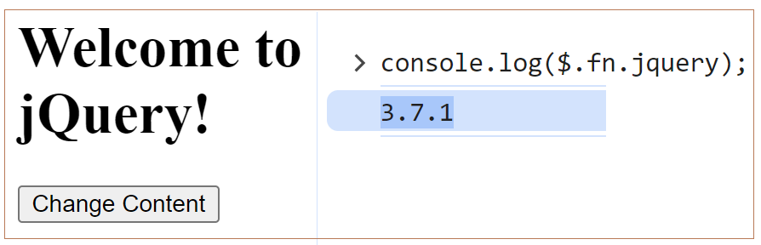

🔧 Debugging Setup Errors
- Issue: jQuery doesn't work
  - Open browser developer tools (usually F12).
  - Go to the Console tab.
  - If you see Uncaught ReferenceError: $ is not defined, this means jQuery is not properly loaded.
  - Fix: Check the script path and ensure it's properly included.

🧠 DOM Manipulation Preview
- Basic jQuery Methods:
- .text(): Get or set text content of an element.
$("#heading").text("New Heading Text");

- .html(): Get or set HTML content.
$("#heading").html("<strong>Bold Text</strong>");

- .css(): Modify CSS styles of an element.
$("#heading").css("color", "blue");
💻 Practical Task: Interactive Webpage
Task: Create a webpage that changes the heading color and content when a button is clicked.
HTML:
<button id="changeContent">Change Content</button>
<h1 id="heading">Welcome to jQuery!</h1>

jQuery:
$(document).ready(function() {
$("#changeContent").click(function()
{
$("#heading").text("You clicked the button!");
$("#heading").css("color", "red");
}
);
});
<!DOCTYPE html>
<html lang="en">
<head>
<title>3] J-Query : Example</title>
<script src="https://code.jquery.com/jquery-3.7.1.min.js"></script>
</head>
<body>
<h1>3] J-Query : Example</h1>
<hr />
<h1 id="heading">Welcome to jQuery!</h1>
<button id="changeContent">Change Content</button>

<script>
$(document).ready(function () {
$("#changeContent").click(function () {
$("#heading").text("You clicked the button!");
$("#heading").css("color", "red");
});
});
</script>
</body>
</html>

🧠 Common Errors & Debugging Tips
Error | Cause | Solution
$ is not defined | jQuery not loaded | Verify the script path or check CDN version
Nothing happens on click | $(document).ready() is missing | Ensure jQuery code runs only after DOM is ready
undefined result when using .text() | Incorrect selector | Double-check the element ID or class

✅ Best Practices & Optimization Tips
- Always use the latest version of jQuery for security and new features.
- Minimize the use of $() on the same element multiple times; cache the selector in a variable.
- For better performance, load jQuery asynchronously using the async or defer attribute.

🎯 Bonus Interview Questions
- What does the $ symbol represent in jQuery?
- How do you integrate jQuery into an HTML document?
- What is the purpose of $(document).ready() in jQuery?
- Explain the difference between .html() and .text() in jQuery.
- How do you use jQuery to modify CSS of an element?

🔍 Knowledge Check
- Which of the following is correct for changing an element’s text in jQuery?
  - a) .setText()
  - b) .text()
  - c) .innerText()
- How would you modify the color of a <p> element with class intro to blue in jQuery?
  - a) $(".intro").css("color", "blue");
  - b) $(".intro").color("blue");
  - c) $(".intro").text("color", "blue");

